1.1
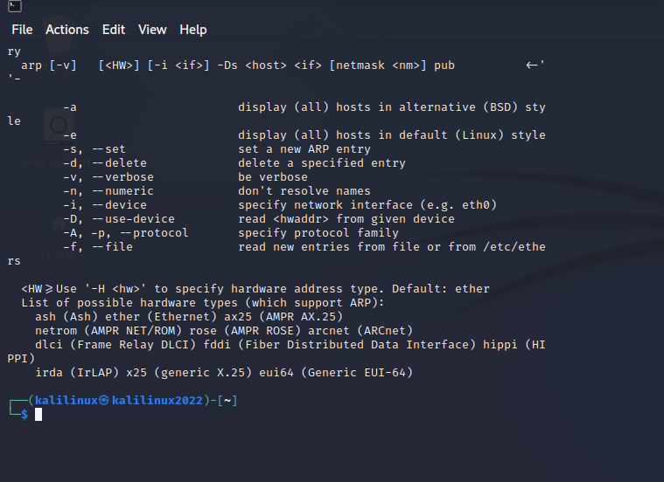
Using arp –-help command:

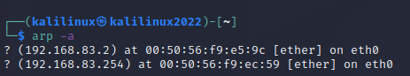
Performing arp -a command:

Pinging 10 times:

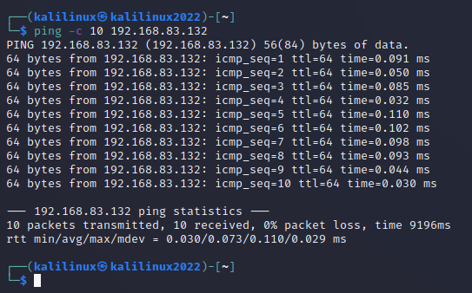
While performing sudo netdiscover:
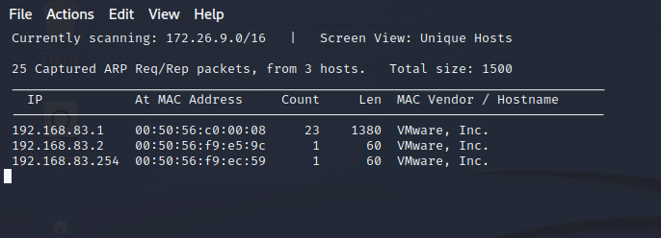

Still while performing netdiscover:
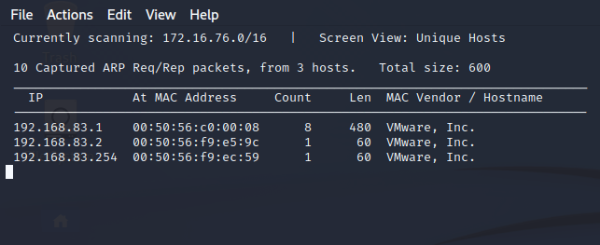

Arp -a command after connecting Metasploit (forgot to connecti it initially):

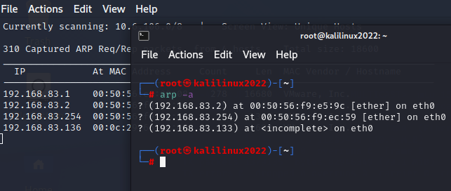

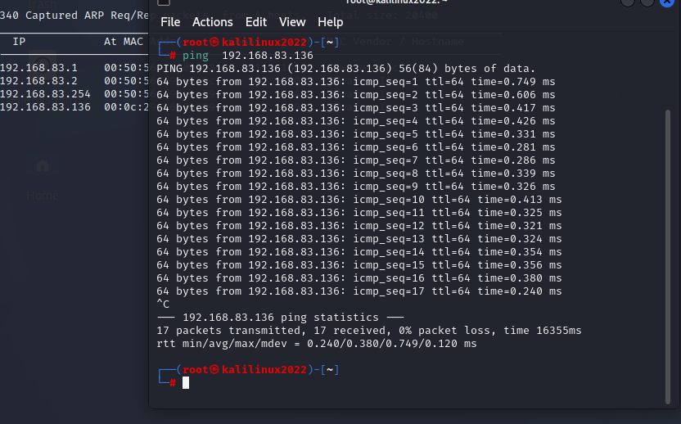
Pinged metalppoitable :

arp capturing after that:

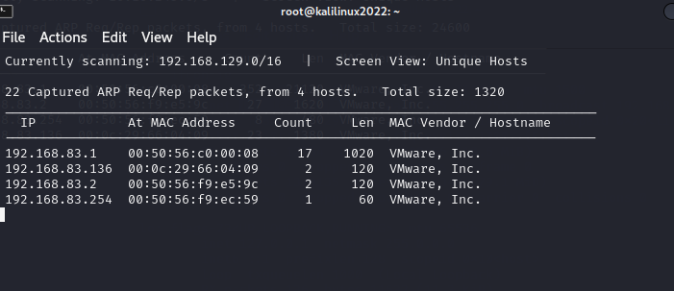

192.168.83.132 kali, 136 meta

Nmap used to scan Metasploit;

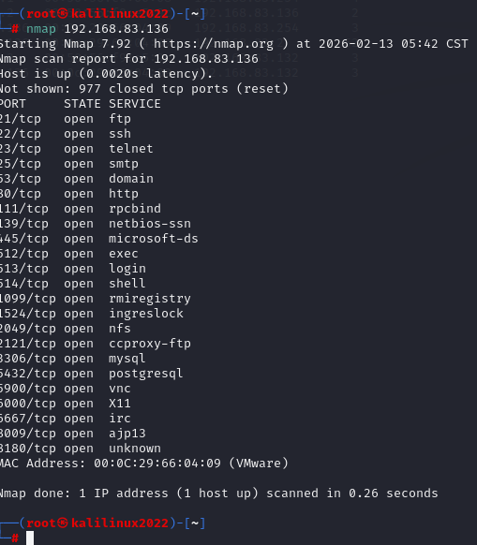

Port 80 is opne: checking by nmap and going to 192/.168.83.1.36

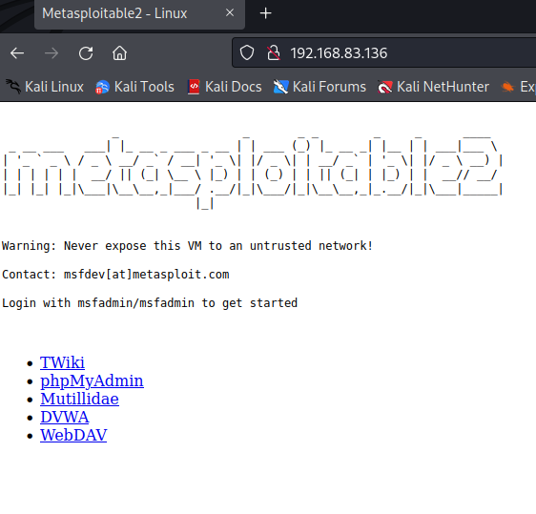

Netdiscover requet:

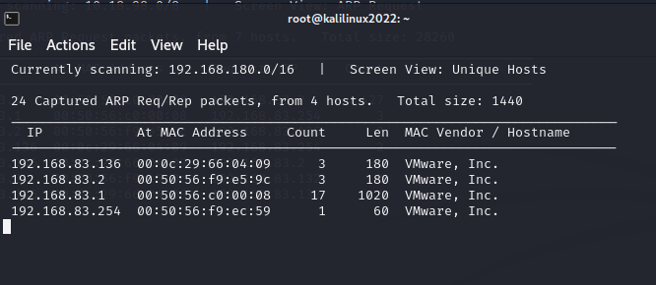

Netstat -nr command shows router ip:

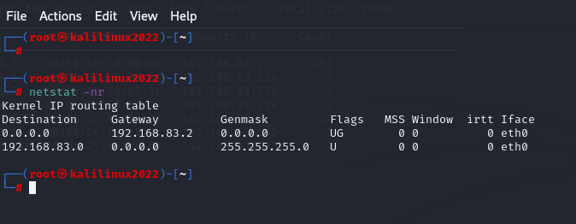

Scanning all on 192.168.83.1/24

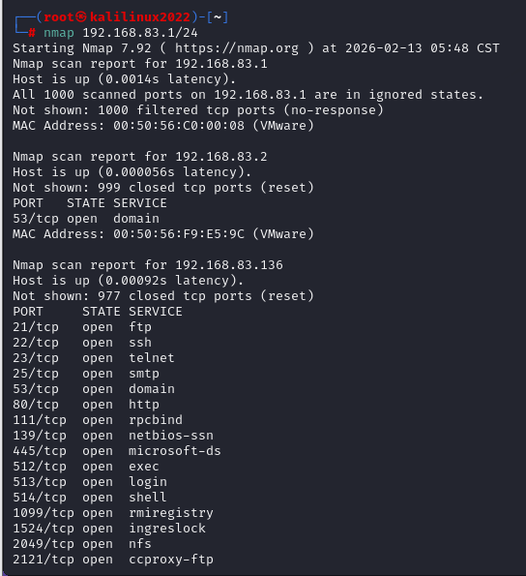

Tcp syn scan without tcp handshake via -sS:

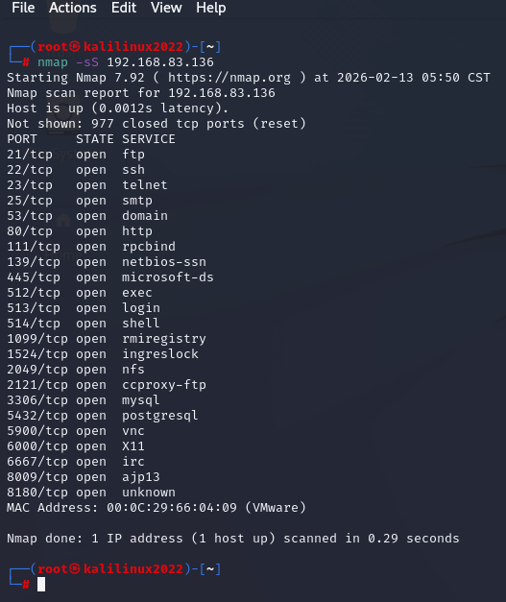

UDP Scan (-sU):
Nmap -sU 192.168.83.136
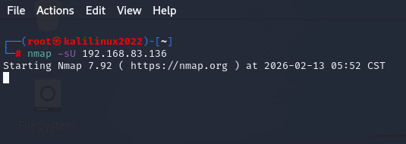
This scan for open udp ports does not work

Detecting O system:

Running: Linux 2.6.X
OS CPE: cpe:/o:linux:linux_kernel:2.6
OS details: Linux 2.6.9 - 2.6.33
Network Distance: 1 hop

Nmap -O 192.168.83.136
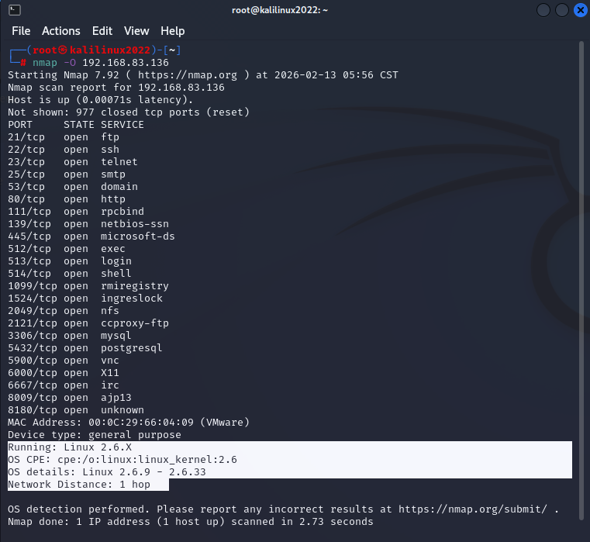

Services version scan:
Nmap -sV 192.168.83.136

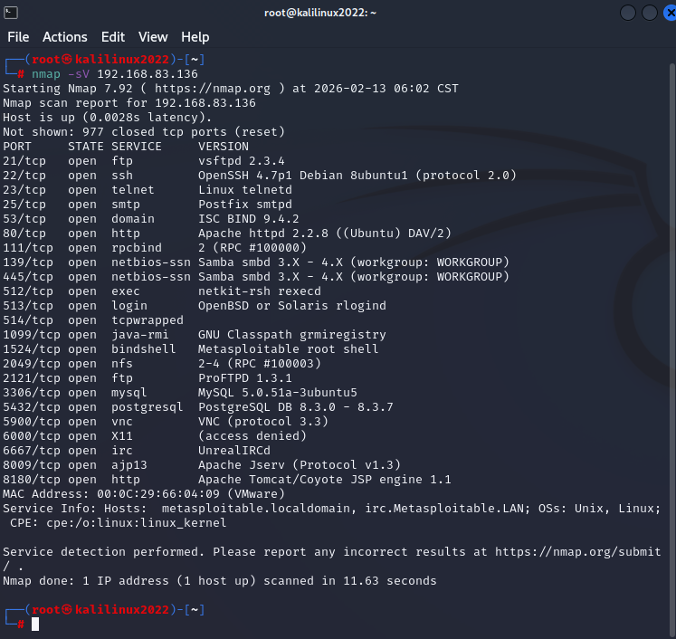

nmap -sV --version-intensity 192.168.83.136
doing versiona internsity:

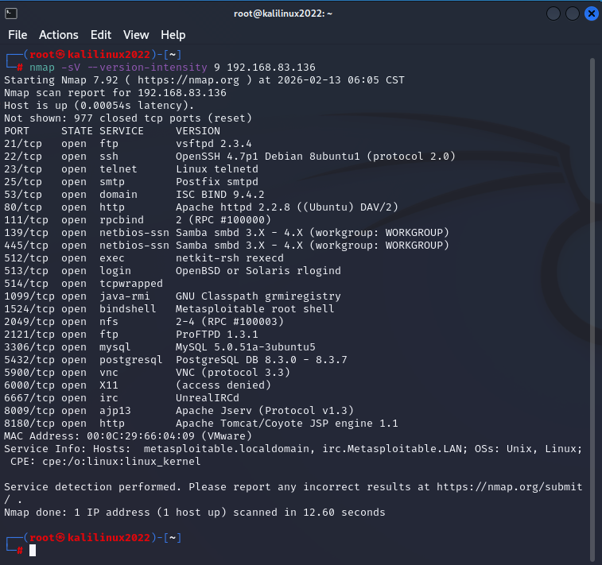

Aggressive scan A:
Nmap -A 192.168.83.136
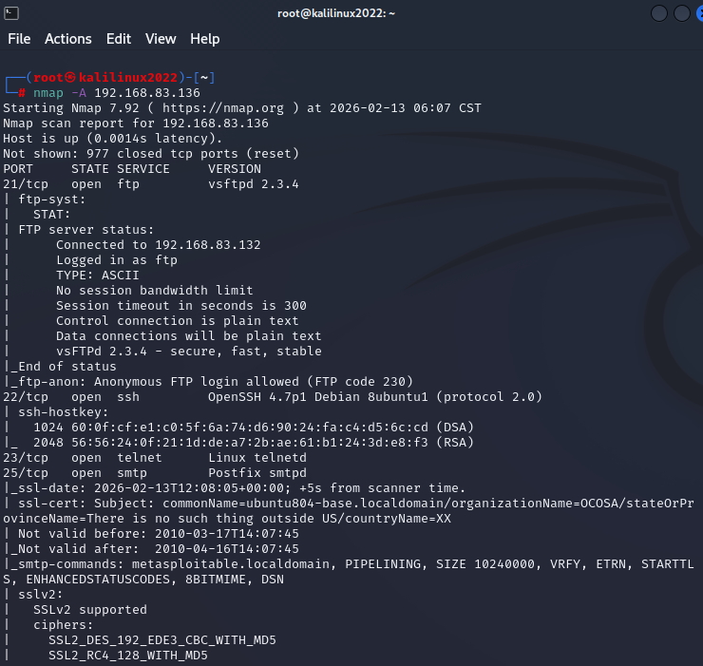

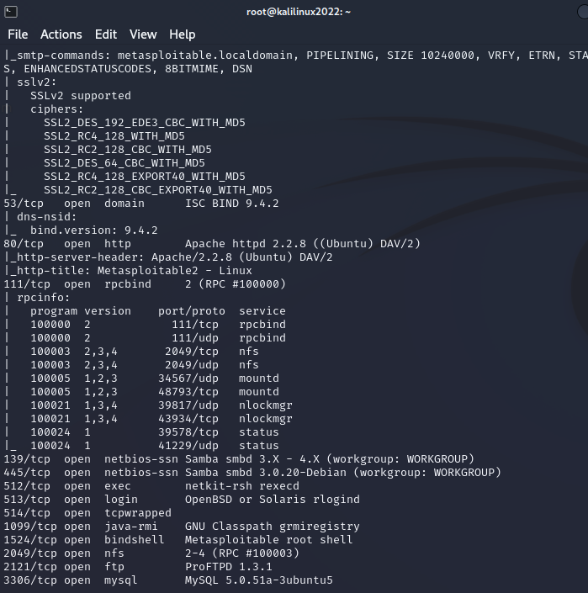

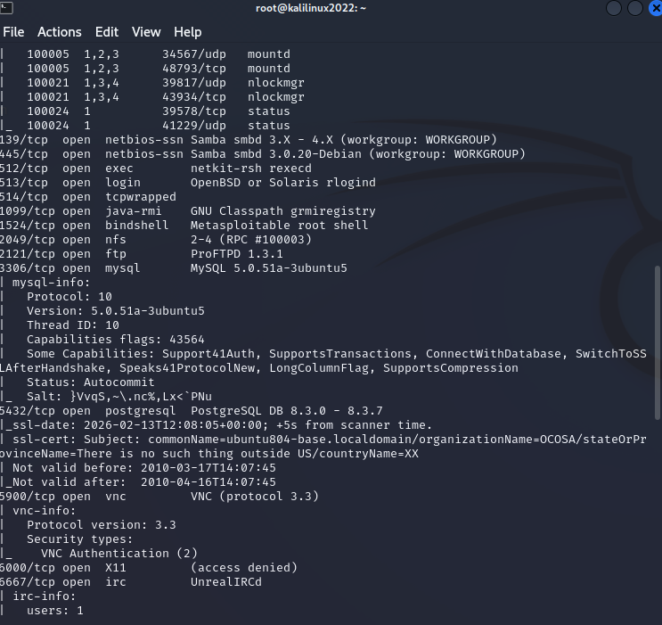

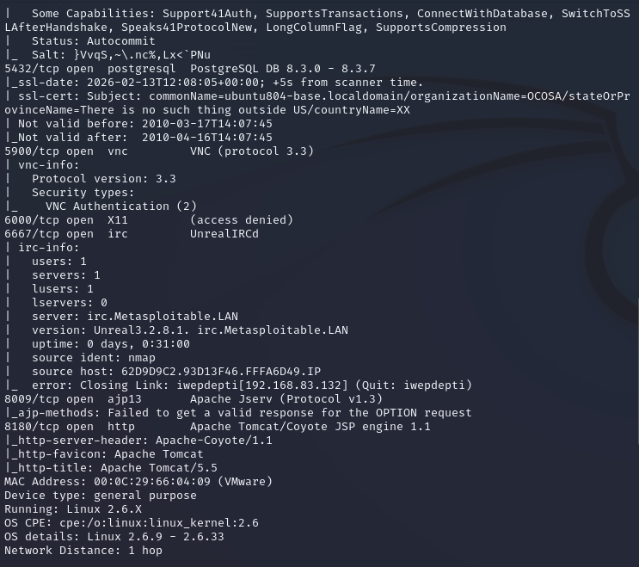

-sn – detecting hosts on the network using the command
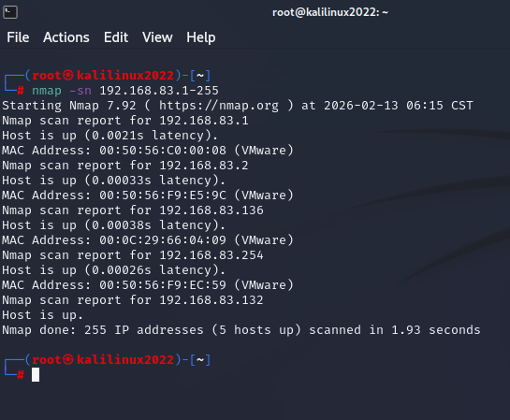
Nmap -sn 192.168.83.1-255

Using nmap -p80,22 192.168.83.136 to find the open ports specific info:

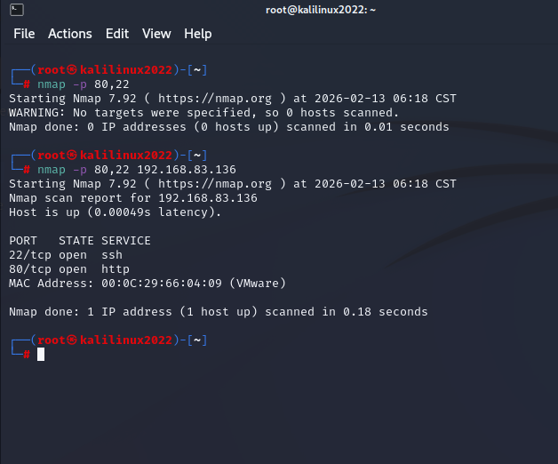

Nmap for scanning all ports from 1 to 65535
Nmap -p 1-65535 192.168.83.136

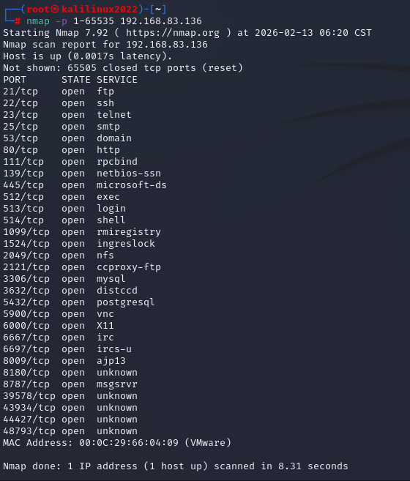

Saving the results of -sS scan into the file output.txt
Nmap -sS 192.168.83.136 >>output.txt and viewing it with cat output.txt ;

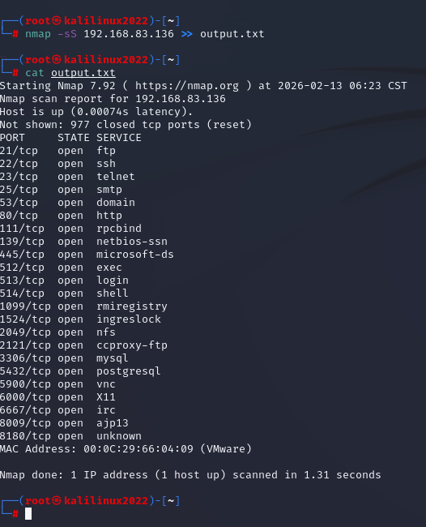

Man namp

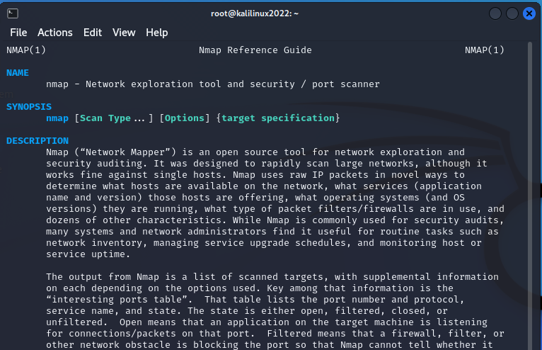

Ls command:



Udp scan
